Failure Simulation screenshots:

- Required ids NOT NULL:
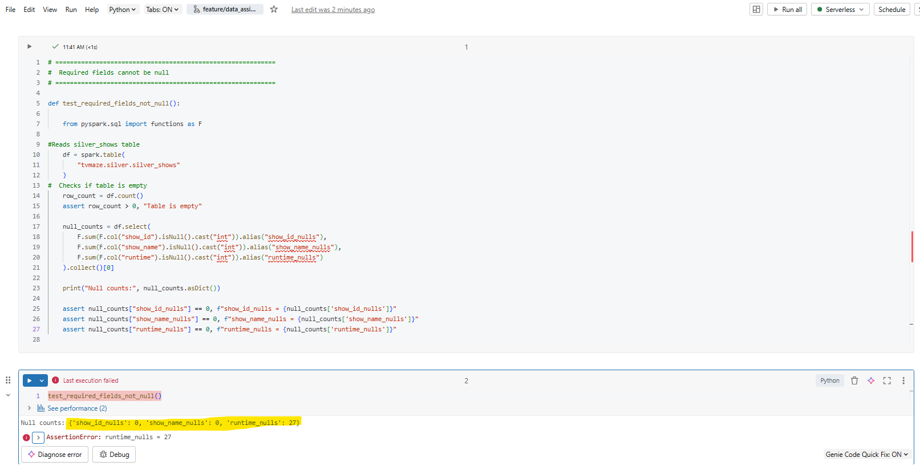

Runtime column has NULL values which is why the test failed.
- Unique show names per id:
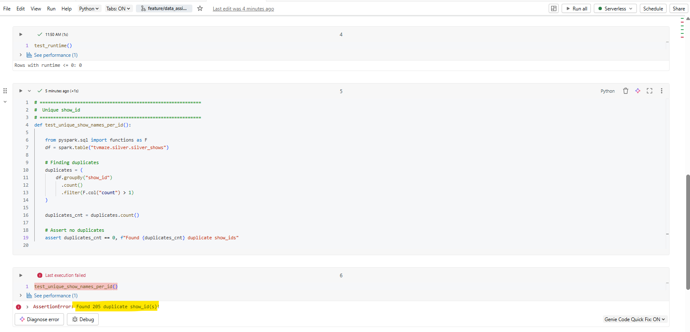
Duplicate values found. Hence, test failed.

